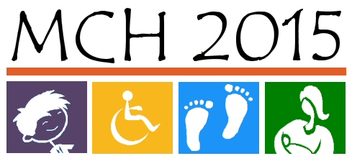
MCH 2015 Needs Assessment
Tool #2: Additional Data Needed – What Are We Missing?

(About 30 minutes) The desired data, if available, will be presented to you at the January 29th meeting. You will use this information to help determine Kansas’ priority needs. (Note: There are limited resources available for additional data analysis or collection.)

Instructions:
Please identify additional data needs for individual indicators on Tool #2. Examples include…
Trend data
Kansas
National
Other states with similar demographics (e.g., Iowa, Nebraska)

Demographic or population data
Race/Ethnicity
Age Group
Gender

Geographic Data
County
City
Population density (e.g., urban, rural)
Region (define the regions per your data request)

Socioeconomic Data
Education (e.g. mother’s education level)

Qualitative Data (e.g., surveys, focus groups, key informant interviews)
Indicator Code / Indicator | Additional Data Needs
 | Contact Information - Name: Email: Phone:
 | Contact Information - Name: Email: Phone:
 | Contact Information - Name: Email: Phone:
 | Contact Information - Name: Email: Phone:
 | Contact Information - Name: Email: Phone:

Indicator Code / Indicator | Additional Data Needs
 | Contact Information - Name: Email: Phone:
 | Contact Information - Name: Email: Phone:
 | Contact Information - Name: Email: Phone:
 | Contact Information - Name: Email: Phone:
 | Contact Information - Name: Email: Phone:

Indicator Code / Indicator | Additional Data Needs
 | Contact Information - Name: Email: Phone:
 | Contact Information - Name: Email: Phone:
 | Contact Information - Name: Email: Phone:
 | Contact Information - Name: Email: Phone:
 | Contact Information - Name: Email: Phone:

